Amrita School of Engineering, chennai Campus.
19CSE101: Computer Systems Essentials
LAB SHEET 3- Operating System
Shell Programming using Regular Expressions

Section 8: Regular Expressions
Regular expressions are a very powerful tool in Linux. They can be used with a variety of programs like bash, vi, rename, grep, sed, and more.

This Section introduces you to the basics of regular expressions.
grep
print lines matching a pattern
grep is a popular Linux tool to search for lines that match a certain pattern. Below are some examples of the simplest regular expressions. This is the contents of the test file. This file contains three lines (or three newline characters).
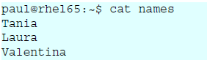
When grepping for a single character, only the lines containing that character are returned.
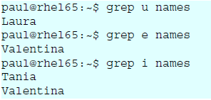
one or the other
PRCE and ERE both use the pipe symbol to signify OR. In this example we grep for lines containing the letter i or the letter a.
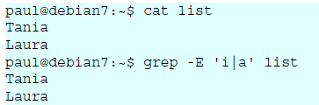

Cat

one or more
The * signifies zero, one or more occurences of the previous and the + signifies one or more of the previous.
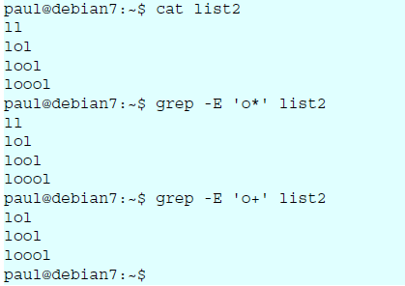
grep
match the start of a string
For the following examples, we will use this file.
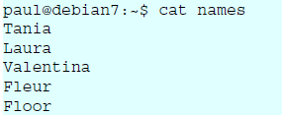

The caret character (^) will match a string at the start (or the beginning) of a line. Given the same file as above, here are two examples.
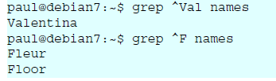

match the end of a string
The two examples below show how to use the dollar character to match the end of a string.
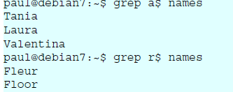

separating words
Regular expressions use a -w option to reference a word separator. Take for example this file:
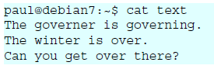
Simply grepping for over will give too many results.
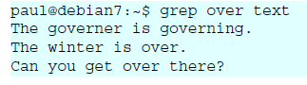
Surrounding the searched word with spaces is not a good solution (because other characters can be word separators). This screenshot below show how to use -w to find only the searched word:
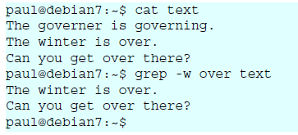

Lab Exercise

- Write shell scripts for the following actions in the given order:
  - Create a file Studdetails with the following contents

Student Alice Essentials 20 PSAT 22 Maths 34 Cultural 25 Physics 80 English 70
Student Bob Essentials 23 PSAT 21 Maths 32 Cultural 18 Physics 18 English 94
Student Boby Essentials 43 PSAT 31 Maths 22 Cultural 8 Physics 76 English 93
Student Clara Essentials 18 PSAT 16 Maths 27 Cultural 12 Physics 34 English 45
Student Dirck Essentials 25 PSAT 23 Maths 48 Cultural 25 Physics 45 English 98+

Student Eve Essentials 8 PSAT 6 Maths 12 Cultural 13 Physics 4 English 5
  - Filter the details of the student Bob
  - Find the number of students with their names containing the letter a, e or i
  - Find the marks of students whose names starts with ‘b’ (case insensitive)
  - Find the names of students whose names starts with ‘b’ and ends with ‘y’ (case insensitive)

- Write a shell script to perform the following actions in the given order:
  - Create a file numericdata with the following contents
Karunagappally 34567 7864 6785
Kollam 56754 6754 7654
Vallikkavu 54328 7548 45675
Trivandrum 16423 6654 6754
Ernakulam 28796 8549 9875
Kayamkulam 35589 75892 3451
kottayam 45557 6773 6547
tirukulum 45675 56476 7896
(Hint : First field is referred as Place second as code1 third as code2 and fourth as code3)
  - Display the details of Places that starts with ‘T’(case sensitive)
  - Display code3 in sorted order(ascending) of the places that start with ‘K’(case insensitive) and ends with am
  - Filter code2 that starts with 6 and ends with 4
  - Filter code2 having one or more occurrence of the digit 6.
  - Filter all code1 having one or more occurrence of the digit 5.
- Write a shell script to perform the following actions in the given order:
  - Write the contents of ls -la to a file named HiddenDetails
  - Write the contents of file HiddenDetails to the file HiddenFiles after replacing multiple occurrences of space with a single space.
  - Using the file HiddenFiles, find the total number of files and folders that starts with ‘p’(case insensitive)
  - Using the file HiddenFiles, find the names of files and folders that starts with ‘.’ and ends with ‘nda’
  - Using the file HiddenFiles, list all the directories
(The first field in ls -la denotes the permissions associated with the file. If the first letter in permission is ‘d’ then it is a directory)
- Write shell program to perform the following actions:
  - Write the contents of the command man sort into a file SortManual.
  - Filter all lines form the file SortManual that starts with ‘compare’.
  - Filter all lines form the file SortManual that ends with ‘sort’.
  - Display the number of lines in SortManual that has the word ‘numeric’.
  - Write the contents of file SortManual to the file sort after replacing multiple occurrences of ‘-’ with a single ‘-’

**************************

